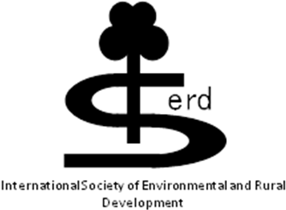
The 5th International Conference on Environmental

and Rural Development

18 - 19 January 2014

“Approaches to Sustainable Rural Development”

ABSTRACT FORM (Deadline: 15 August 2013)

Title (Dr/Mr/Mrs/Ms): ___ Last Name_____________________________First Name: ____________________
Institution: ________________________________________________________________________________
Position held in Institution: ___________________________________________________________________
Contact/Mailing Address: ____________________________________________________________________
_________________________________________________________________________________________
Tel no.: _________________________________ Fax: ______________________________________
E-mail: _______________________________________
Title of your contribution (limit 12–15 words): _____________________________________________________
_________________________________________________________________________________________
Author’s Name(s): __________________________________________________________________________
_________________________________________________________________________________________
Please type your abstract below (maximum 300 words, describing rationale, objectives, methods, results and conclusions).

Keywords_____________, ______________, _____________, ______________, ______________
Please complete this Form and send it via email as attachment to:
Email: 5thicerd@rmutt.ac.th

Note: Abstract accepted for either oral or poster presentation will all be included in the ‘Book of Abstracts’ of the conference.

